**EXPERIMENT: 4**

**1.TITLE:**

Performing JDBC operations.

**2.OBJECTIVE:**

1. To connect SQL database using JDBC.
2. To perform read, write, delete and modify in a SQL database using JDBC.

**3.THEORY:**

Java Database Connectivity is a technology that allows Java applications to interact with relational databases and execute SQL queries against the databases.

There is a standard process followed to execute SQL Queries .Following lists the basic steps involved in any JDBC program.

* Import necessary packages.
* Load and register the Driver.
* Establish the connection to the databases
* Create the statements
* Execute the statements.
* Process the results.
* Close the statements.
* Close the connection.

**4.IMPLEMENTATION:**

PROGRAM 4.1. To connect database using JDBC.

*package lab4;*

*import java.sql.*;*

*public class Lab4 {*

*public static void main(String[] args) throws Exception {*

*try{*

*Class.forName("com.mysql.cj.jdbc.Driver");*

*Connection con=DriverManager.getConnection("jdbc:mysql://localhost:3306/library",*

*"root","krishna@123");*

*Statement stmt=con.createStatement();*

*ResultSet rs=stmt.executeQuery("Select * from book");*

*while(rs.next())*

*{*

*System.out.print(rs.getString(1));*

*System.out.print(","+rs.getString(2));*

*System.out.print(","+rs.getString(3));*

*System.out.print(","+rs.getString(4));*

*System.out.print(","+rs.getString(5));*

*System.out.println(","+rs.getString(6));*

*}*

*stmt.close();*

*con.close();*

*}*

*catch(Exception e)*

*{*

*e.printStackTrace();*

*}*

*}*

*}*

OUTPUT:

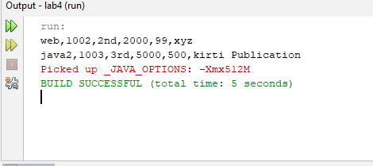

**PROGRAM 4.2**. To perform read, write, delete and modify in a SQL database using JDBC.

*package lab4;*

*import java.sql.*;*

*import java.util.Scanner;*

*public class jdbc {*

*Connection con;*

*public void connection() throws Exception*

*{*

*try{*

*Class.forName("com.mysql.cj.jdbc.Driver");*

*con=DriverManager.getConnection("jdbc:mysql://localhost:3306/library",*

*"root","krishna@123");*

*}*

*catch(Exception e)*

*{*

*e.printStackTrace();*

*}*

*}*

*public void read()*

*{*

*try{*

*Statement stmt=con.createStatement();*

*ResultSet rs=stmt.executeQuery("Select * from book");*

*while(rs.next())*

*{*

*System.out.print(rs.getString(1));*

*System.out.print(","+rs.getString(2));*

*System.out.print(","+rs.getString(3));*

*System.out.print(","+rs.getString(4));*

*System.out.print(","+rs.getString(5));*

*System.out.println(","+rs.getString(6));*

*}*

*stmt.close();*

*}*

*catch(Exception e)*

*{*

*e.printStackTrace();*

*}*

*}*

*public void write()*

*{*

*try{*

*Statement stmt=con.createStatement();*

*int re=stmt.executeUpdate("Insert into book values('java',1005,'3rd',"*

*+ "5000,500,'kirti Publication')");*

*System.out.println(re+" row(s) added");*

*stmt.close();*

*}*

*catch(Exception e)*

*{*

*e.printStackTrace();*

*}*

*}*

*public void delete()*

*{*

*Scanner sc=new Scanner(System.in);*

*System.out.println("write bookid of data to be deleted");*

*int rn=sc.nextInt();*

*try*

*{*

*PreparedStatement psmt=con.prepareStatement("Delete from book"*

*+ " where bookid=?");*

*psmt.setInt(1,rn);*

*int re=psmt.executeUpdate();*

*System.out.println("The row is deleted");*

*psmt.close();*

*}*

*catch(Exception e)*

*{*

*e.printStackTrace();*

*}*

*}*

*public void update()*

*{*

*Scanner sc=new Scanner(System.in);*

*System.out.println("write the bookid of whose stock is to be updated to be updated");*

*int rs=sc.nextInt();*

*try*

*{*

*PreparedStatement psmt=con.prepareStatement("update book set stock=stock-1 where "*

*+ "bookid=?");*

*psmt.setInt(1,rs);*

*psmt.executeUpdate();*

*System.out.println("The row is updated");*

*}*

*catch(Exception e)*

*{*

*e.printStackTrace();*

*}*

*}*

*public static void main(String[] args) {*

*jdbc j=new jdbc();*

*try*

*{*

*j.connection();*

*j.write();*

*j.read();*

*j.delete();*

*j.read();*

*j.update();*

*j.read();*

*}*

*catch(Exception e)*

*{*

*e.printStackTrace();*

*}*

*}*

*}*

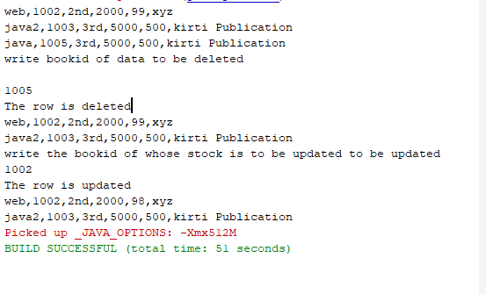

**5.OUTPUT AND DISCUSSION:**

* The SQL database is connected using JDBC in program 4.1.
* The various operations of database are performed usin JDBC in program 4.2.

**6. CONCLUSION:**

The SQL database is connected and its various operations is operated using JDBC successfully.